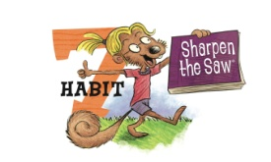
Sophie Squirrel missed out on a lot of fun with friends because she was too tired. Here are some ways for you to Sharpen the Saw.

- For two nights in a row, go to bed early and see how great you feel when you wake up!
- For one whole week, read for twenty minutes every day.
- Today go play with someone who you haven’t played with for a long time.
- Go to one of your favorite spots in nature. When you get there, think about all the things in your life that make you happy, like your grandma, your dog, a fun toy, or playing with your friends.

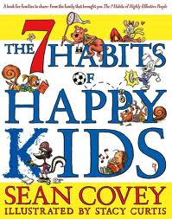

The 7 Habits and Ideas for ways to use them are reprinted from The 7 Habits of Happy Kids by Sean Covey, Illustrated by Stacy Curtis.
Several copies are available for check out from the Crestline Library.

The Seven Habits of Happy Kids…

Habit 1
Be proactive: You’re in Charge

Habit 2
Begin with the End in Mind: Have a Plan

Habit 3
Put First Things First: Work First, Then Play

Habit 4
Think Win-Win: Everyone Can Win

Habit 5
Seek First to Understand, Then to Be Understood: Listen Before You Talk

Habit 6
Synergize: Together is Better

Habit 7
Sharpen the Saw: Balance Feels Best

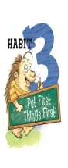
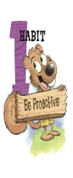
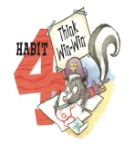

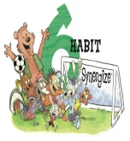
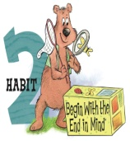
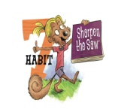

The Seven Habits
Reference for Kids
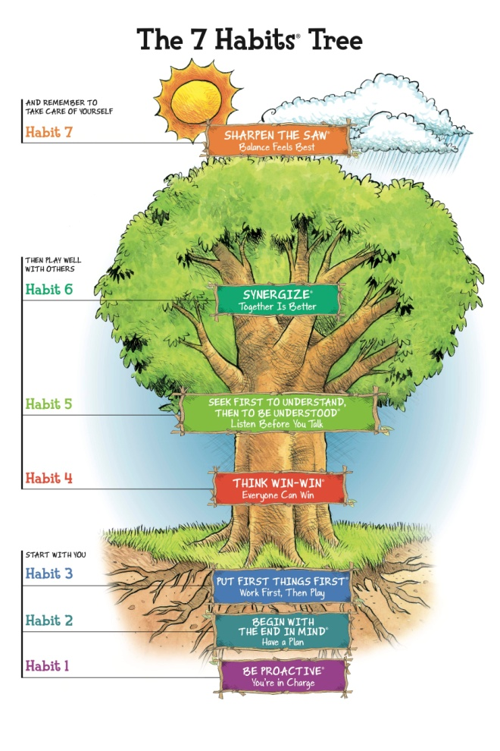


The 7 Habits of Happy Kids

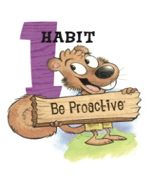
Sammy Squirrel has several Baby Steps to help you learn Habit 1. Here are a few of Sammy’s ideas.

- The next time you feel bored, do something nice for someone else.
- Try doing something today that you’ve always been scared to do. Make a new friend, raise your hand in class, clean the toilet
- The next time you get mad and want to say something mean or rude, bite your tongue instead and don’t say it.
- If you do something wrong, say you’re sorry before someone asks you to apologize.

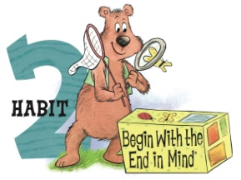
Goob Bear had a plan to get the things he wanted. Listed below are some ways Goob wants to help with Habit 2.

- Lay out your clothes for tomorrow before you go to bed tonight.
- Get out a pencil and piece of paper and write down three goals you want to do. Put the paper in a safe place where you can see it.
- Tell your mom or dad what you want to be when you grow up
- We all have something we need to get batter at. Pick one thing you need to do better. Start doing it.

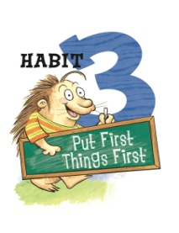
Pokey Porcupine didn’t use Habit 3 when preparing for his spelling test. Here are a few ways he suggests practicing Habit 3.

- What are some of your most important jobs or responsibilities? Practicing the piano? Making your bed? Doing your homework? Taking out the garbage? Talk about them with your mom and dad.
- Tomorrow surprise you’re your parents and do your chores before they even ask.
- The next time you have a lot of homework to do, do the hardest part first.
- Think of something you’ve been putting off for a long time. Go do it right now.

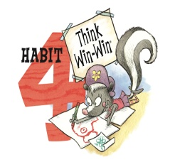
Lily Skunk came up with a Win-Win when planning her garden. Here are some ways for you to make it a Win-Win.

- Ask an older person what the golden rule is. After you know, try it out on someone.
- Try to go one whole day without sulking, pouting, or feeling sorry for yourself.
- The next time you want to argue or fight with someone ask, “How can I make you happy too?”
- Make a “wish poster.” See The 7 Habits of Happy Kids book for details.

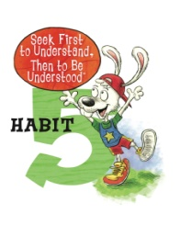
When Goob lost his bug net, Jumper Rabbit helped him find it. Jumper has some ways to help you with Habit 5

- Try to go one whole hour without talking even once. Instead, just watch the people around you and listen to what they are saying. Good luck!
- Think of someone in your life who you think is a good listener. Your grandma? Your dad? Your best friend? What do they do that makes them a good listener?
- The next time one of your friends is sad, notice his/her eyes or the way he/she holds his body. Tell them you know they are sad and you want to help.

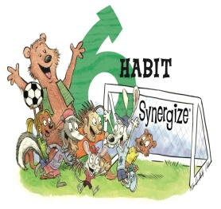
Tough soccer game for our gang of friends. They used Habit 6 to win the game. Here are some ways for you to Synergize.

- Write down three things that you’re really good at. Then write down three things that someone else you know is good at.
- Watch your favorite sports team play a game. Pay extra attention to how all the players work together as a team.
- Talk about what makes a bad team member and what makes a good team member.

Turn the page to learn about Habit 7

